


Backend Development, 5cu
Study diary
Leo Latvala

Contents
1 Week exercises 3
1.1 Written answers to questions 3
1.2 The first weekly exercises here, relevant code, explanations and screenshots (the same applies in following week exercises). 3
2 Week excercises 4
3 Week exercises 5
4 Week exercises 6
5 Week exercises 7
Sources used with exercises 8

Important general note for all weekly exercises: List all external sources you’ve used to implement the task (github, tutorialspoint, other projects, network sites, blogs etc..)

Week exercises

Written answers to questions
Exercise 1 :
- I checked the versions of node, npm, and git as well as installing the extensions required. Please refer to figures 1.1.1-5.
- I tried out the Integrated terminal which is already quite familiar to, but I still tried running a test file with it, please refer to figure 2.1. I also created a new repo for version control , please refer to figures 1.2.2 and 1.2.2.
  - What problem does REST client resolve ? The main issue it solves is that it allows for the developer/engineer to quickly send HTTP requests via VSCode rather than having them use a browser to check out the output.
  - What is the difference between ESLint and Prettier ?
The main difference between ESLint and Prettier is that Prettier doesn’t have any integrated debugger unlike ESLint which allows for.
  - Which VSCode feature do I think will be most useful when developing a backend ? I believe that the extensions and the source control features will be the most useful in future development.

  - The one convenience that REST Client has is that you are able to have your own set of CRUD operations one after the other unlike in Postman were you need to specify individually which CRUD operation to execute.
  - One convenience that Postman provides is its UI, which introduces an intuitively easier method for creating and executing CRUD operations.
  - I personally found Postman to be the preferable to compared to REST Client. One of the main reasons is that it provides further information that could be viewed e.g. the headers unlike in the REST Client.

Exercise 2 :
Steps 1-4 :
I created the project and installed express, I implemented the needed information and successfully got the movies information as well as a status 200 OK. One problem I did encounter was not fully understanding were the status code was printed, so I tried forcefully just printing both values until I realized that the status is printed separately in Postman. Please refer to figures 2.1.1-2.
Step 5 :
I used found the movies ids by simply defining the id’s as numbers and the movies as the movies set ids with a simple if statement to check whether the movie exists or not. Please refer to figures 2.2.1-3.
Step 6 :
I tested the post operation by adding the newly released movie “Lapin sota”. One problem I did encounter here was finding the correct field where to input the content of the operation, I managed to find it by simply testing and trying out all of the possible input fields and realizing I was trying to send the content in a text format rather than a JSON format.Please refer to figure 2.3.1-2
Step 7 :
Here I simply removed the title of the movie and I received the expected error. Please refer to figure 2.4.1.
Step 8 :
The movie was deleted and not found by the server. The reason behind why the data is no longer available after the server was restarted, was due to the data being saved in the RAM of the server and not being saved to any empty arrays within the server.

Exercise 3 :
Steps 1-6 :
I succeeded in creating all of the GET and POST requests successfully. Please refer to the original requests.http file in figure 3.1.1.
Tests :
GET /movies : Figure 3.1.2
GET /movies/:id : Figure 3.1.3
GET (invalid)/movies/:id : Figure 3.1.4
POST /movies : Figure 3.1.5
GET /movies : Figure 3.1.6
POST (invalid)/movies : Figure 3.1.7

The first weekly exercises here, relevant code, explanations and screenshots (the same applies in following week exercises).

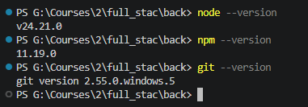
Figure 1.1.1
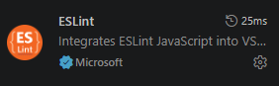
Figure 1.1.2
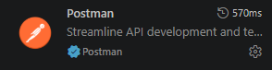
Figure 1.1.3
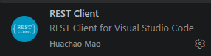
Figure 1.1.4
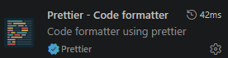
Figure 1.1.5

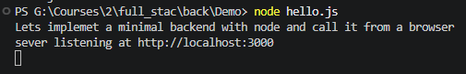
Figure 1.2.1
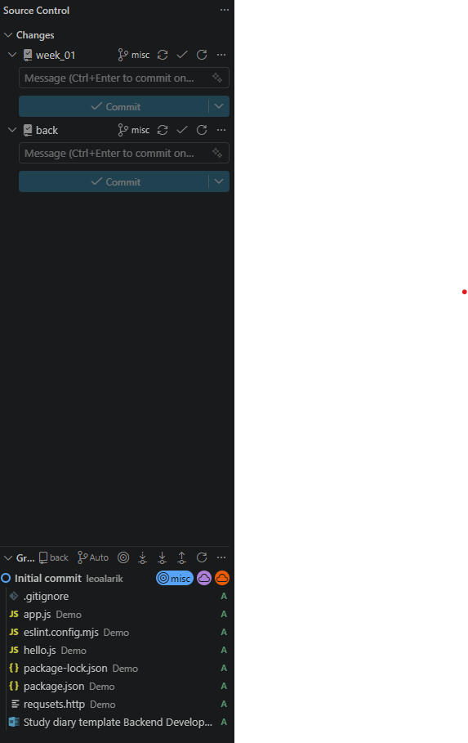
Figure 1.2.2

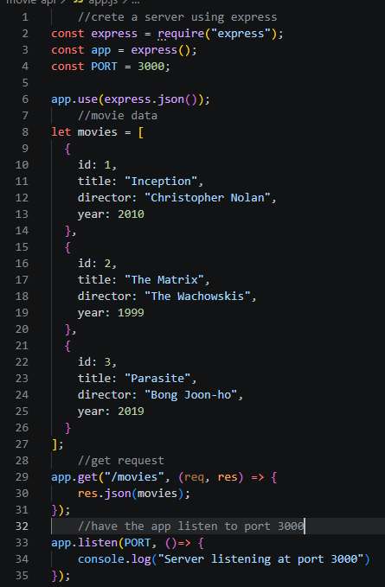
Figure 2.1.1
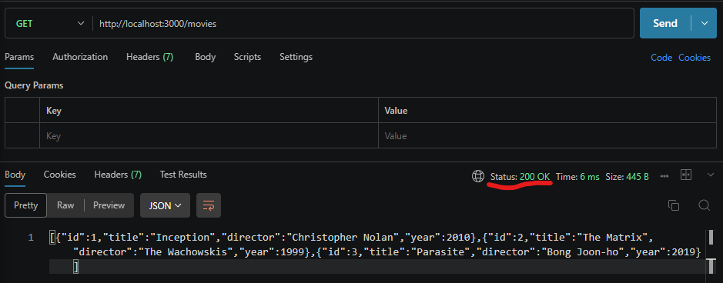
Figure 2.1.2

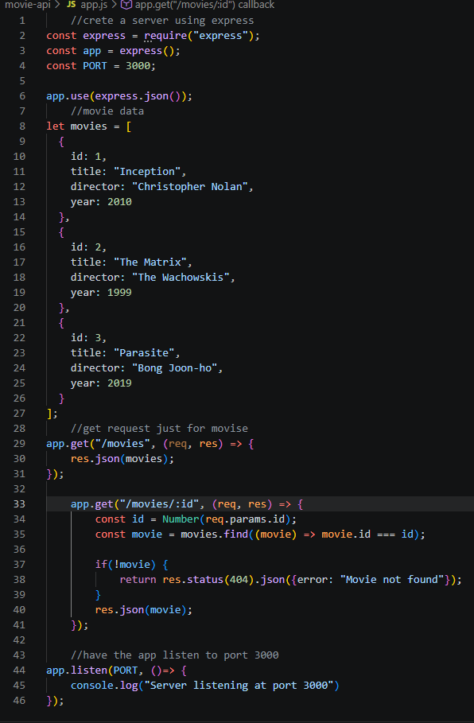
Figure 2.2.1
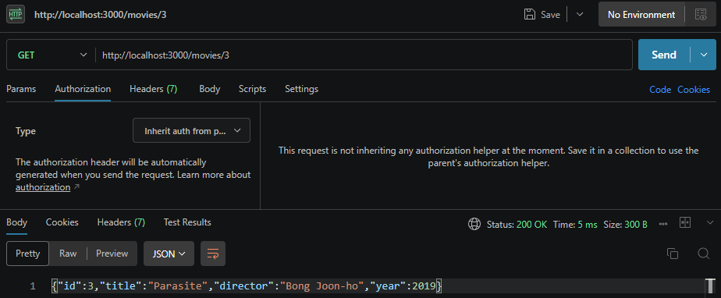
Figure 2.2.2
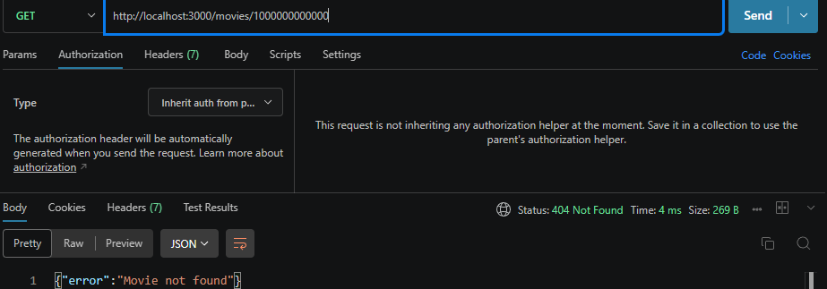
Figure 2.2.3
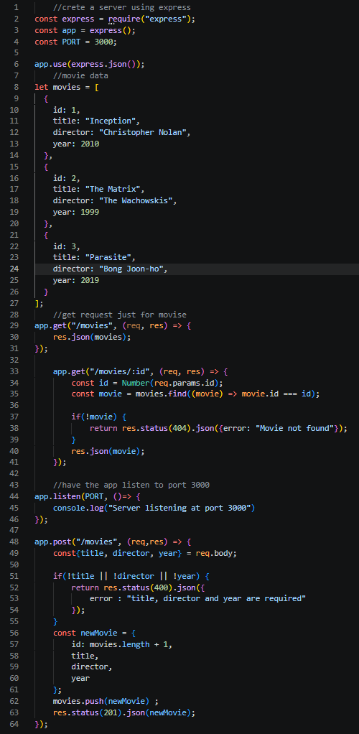
Figure 2.3.1
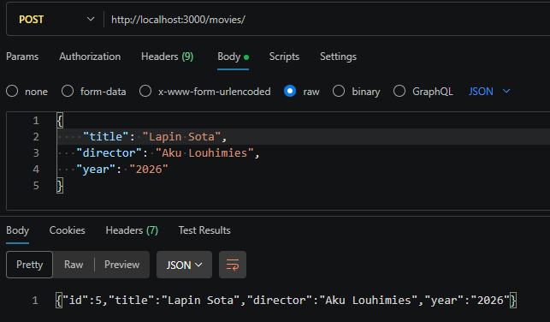
Figure 2.3.2
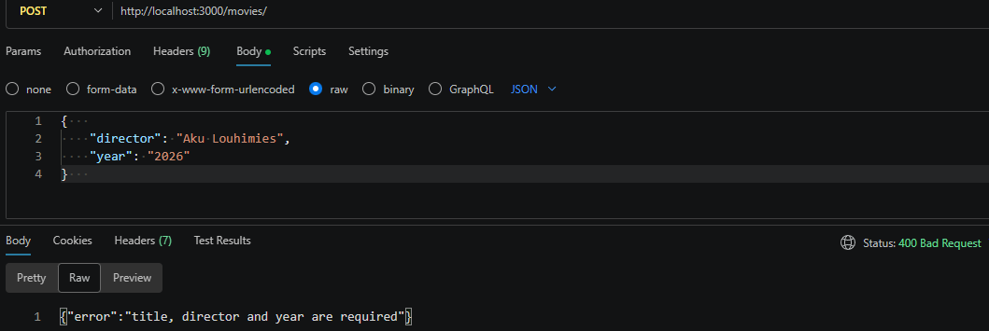
Figure 2.4.1
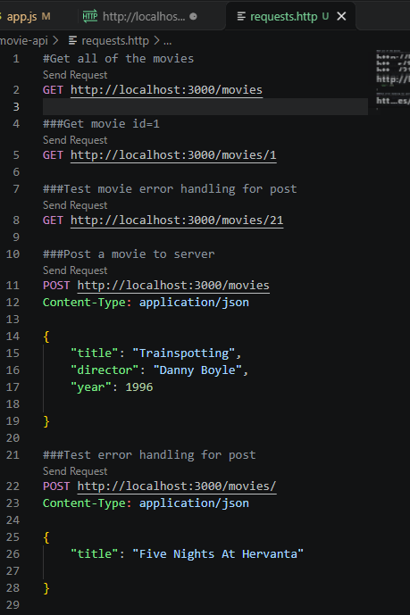
Figure 3.1.1
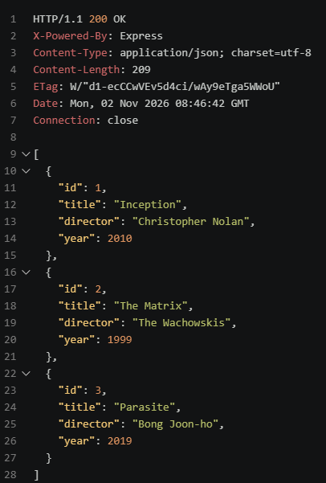
Figure 3.1.2
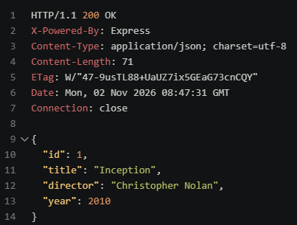
Figure 3.1.3
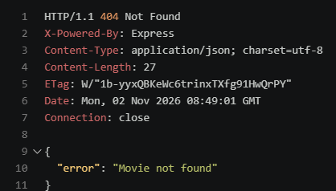
Figure 3.1.4
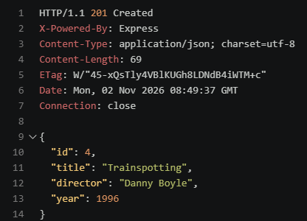
Figure 3.1.5
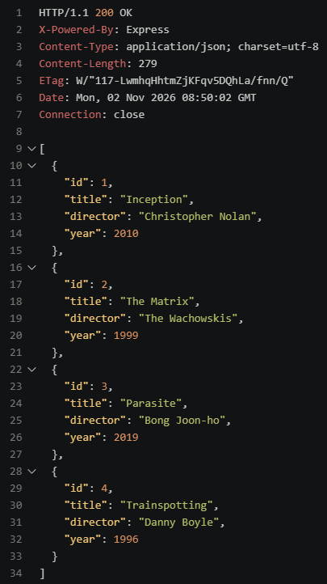
Figure 3.1.6
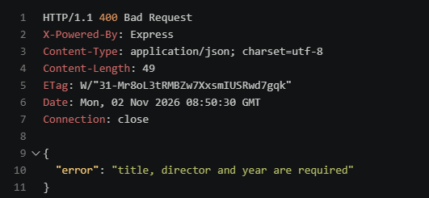
Figure 3.1.7

Week excercises
2.1 : Written answers
Task 1
  - : All endpoints still worked from last week. Please refer to figures 1.1.1-4.
  - : I tested the 3 different return codes for PUT and they worked. Please refer to figures 1.2.1-3.
  - : I implemented the PATCH method and tested it with 3 different scenarios. Please refer to figures 1.3.1-3
  - : The DELETE operation worked with 2 successful tests. Please refer to figures 1.4.1-2.

    - Replacing a resource changes most of the originals resources attributes e.g. the title , director and the year but wont change the id pointer for that said resource object. Partially updating a resource only changes a few designated attributes of the resource object but not all of them.
    - The PUT operation needs all of the movies properties, due to the fact that the operation itself is replaces all of the objects attributes, in order for this to work the operator needs all of the movies attributes.
    - The PATCH operation only partially updates a resource object, unlike with the PUT operation which completely updates the object.
    - If a certain field of the object is missing the server will throw a bad request error(400) for the missing attributes.
    - The object to be updated will be updated despite the missing attribute.

Task 2
2.2 : I implemented the validationMovies function. One issue that I had when I was making the function was forgetting to actually check whether or not a body length was 0 to check if the title was missing. Otherwise the function worked. Please refer to figure 2.2.1.
2.3 : I implemented the error codes to the respective operators. Please refer to figures 2.3.1-2

Task 3 :
I added the sort and filter methods and tested them. Please refert to figures 3.1.1-3.

Task 4 :
4.1 : If the middleware were to be missing, the req.body wouldnt be defined an so express wont parse the request bodies on its own.
4.2 : The middleware is executed at the I tested the initial logger with expected results, please refer to figures 4.2.1-4.
4.3 :
The middleware runs once for each request, at the point in which said request arrives.
After the middleware is run by express in the order they were registered, next() essentially is what would move the request forward.
If next() is removed and no response is sent the request would hang.
4.4-5 : I tested both the unnown route and error handling middleware, for testing the internal server error, I added a small get operation to call on the error. Please refer to figures 4.4.1-3

Task 5
Get all movies | Figure 5.1
Get one movie | Figure 5.2
Get missing movie | Figure 5.3
Create valid movie | Figure 5.4
Create invalid movie | Figure 5.5
Replace movie with PUT | Figure 5.6
PUT with missing properties | Figure 5.7
Partially update movie | Figure 5.8
Delete existing movie | Figure 5.9
Delete same movie | Figure 5.10
Filter by director and year | Figure 5.11
Use invalid minYear | Figure 5.12
Request unknown route | Figure 5.13

Task 6
Implementation :
End points :
GET /movies:
Returns the list of movies, optionally filtered and sorted with query parameters.
GET /movies/:id:
Returns one movie by id, or a 404 MOVIE_NOT_FOUND if it doesn’t exist.
POST /movies:
Validates the body and creates a new movie, returning it statu 201.
PUT /movies/:id:
Replaces an existing movie entirely, so all fields are required and validated. It returns 404 if the id is unknown.
PATCH /movies/:id:
Updates only the fields you send, after validating them. It returns 404 if the id is unknown.
DELETE /movies/:id:
Removes the movie and returns 204 with no body, or 404 if the id is unknown.
GET /crash:
Test route that throws an error on purpose to trigger the 500 handler.
Validation rules :
title : must be anon empty string, needed for POST and PUT
director : must be a non empty string , required by POST and PUT
year : must be an integer between 1888 and 2026

Middleware :
I explained the characteristics and jobs of express.json() and next() in task 4
Comparatively looking at my reqLogger compared to morgan, is that morgan simply reduces the amount of code needed to be written in my opinion.
The reason why middleware order matters is due to the fact that the middleware allows for all other test cases or validation possibilites to be executed in the upper layers of the code. Essentially the middleware is the last resort to error handling.

Testing :
I went through the relevant filtering test cases in task 3 , I tested morgan in task 4 and the final tests in task 5.

Git hub repo link : https://github.com/JebMN/backend
Reflection :
1 : The most important difference between PUT and PATCH is that PUT specifically replcaes an entire resource object, unlike PATCH were it paratially updates or ”patches” a resource object.
- : The reason why backend input should always be validated is so that
- : The purpose of middleware is to allow for error handling and telling users that a certain resource or path that they wished to look for is invalid or doesnt exist. Another reason is for possible error handling if a server doesnt have a certain attribute it will be able to tell the user a server error occured.
- : Unsuccessful requests should also be tested in order to conclude that the backends error handling does work, so that once the backend is shipped the program wont crash if a user gives invalid input that may affect the rest of the application.
- : I would honestly say that the most difficult part of the assignment was figuring out how to test the query parameters, since I had issues trying to create the actual queries with directors names having spaces, but I overcame to issue with simply going through the slides.
- : The most important thing I learned was to know to keep the middleware at the very end of the code, beacuase I didnt pay attention to it and had some issues regarding that.

2.2 : The exrcises, relevant code, explanations and sceenshots.
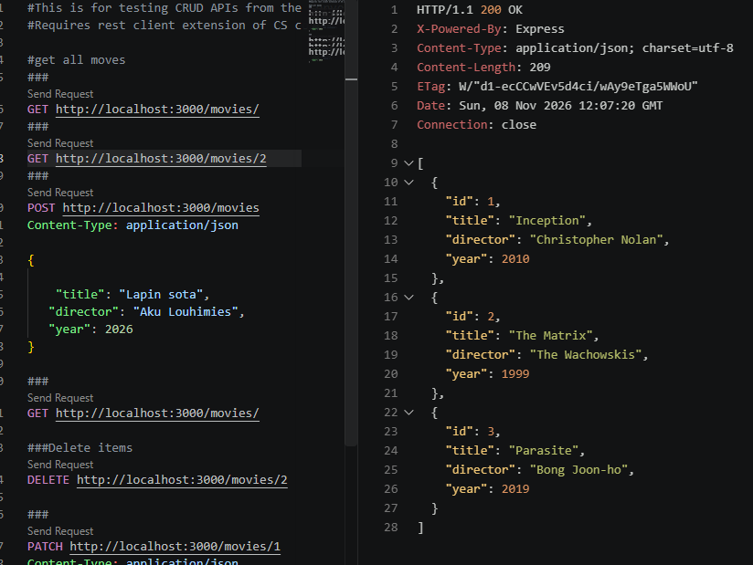
Figure 1.1.1
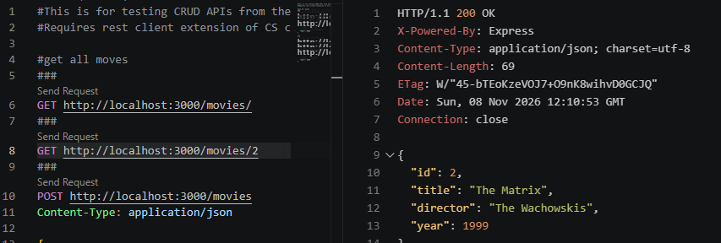
Figure 1.1.2
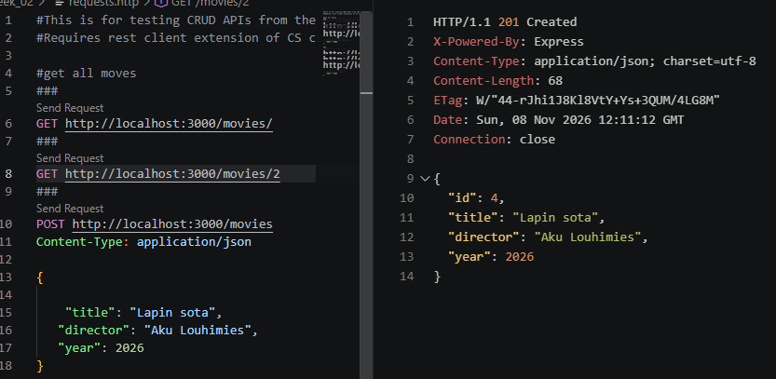
Figure 1.1.3
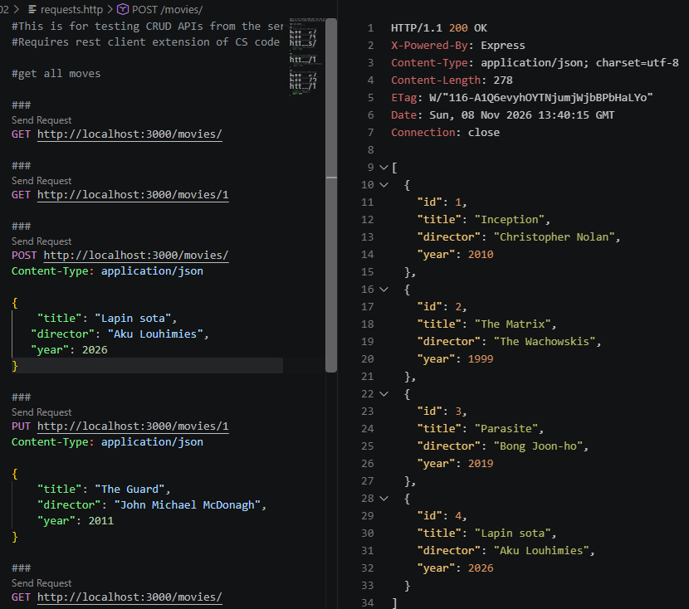
Figure 1.1.4

Figure 1.2.1
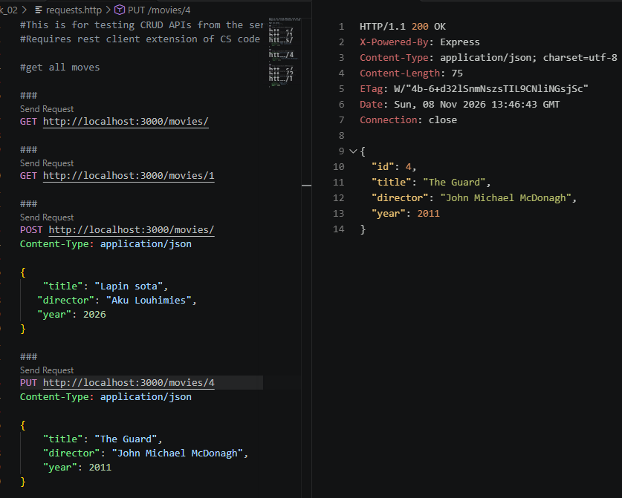
Figure 1.2.2
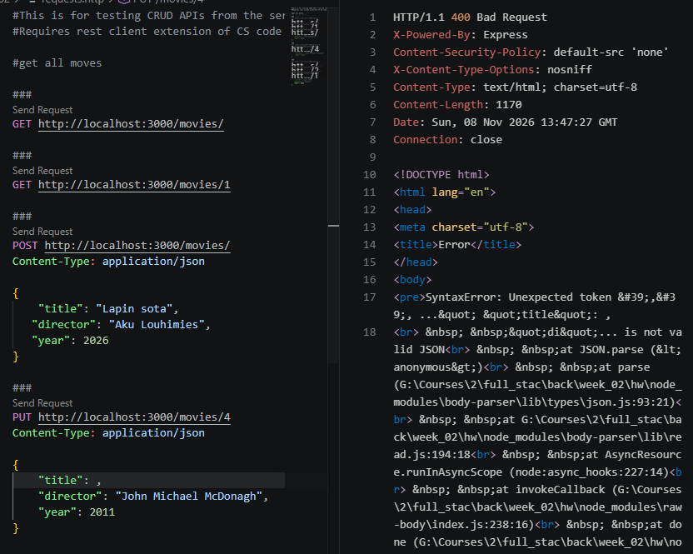
Figure 1.2.3
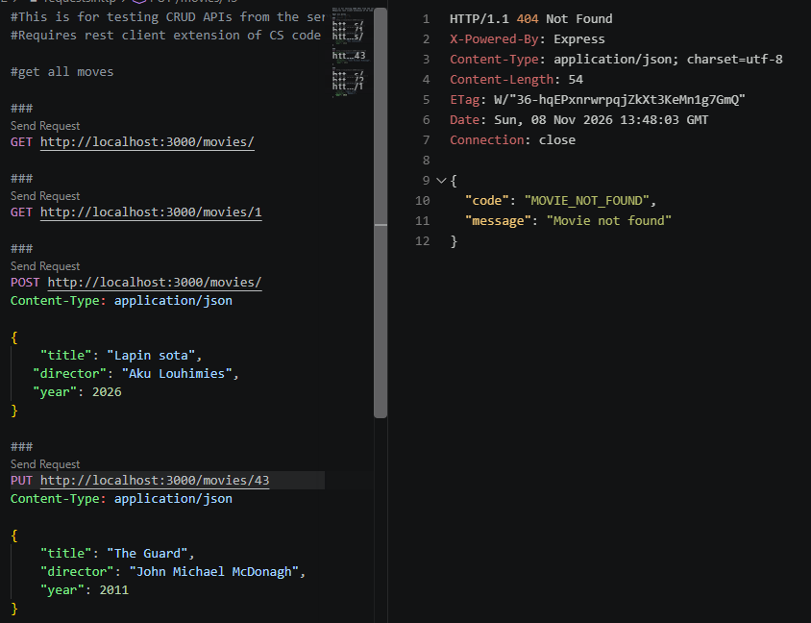
Figure 1.2.3
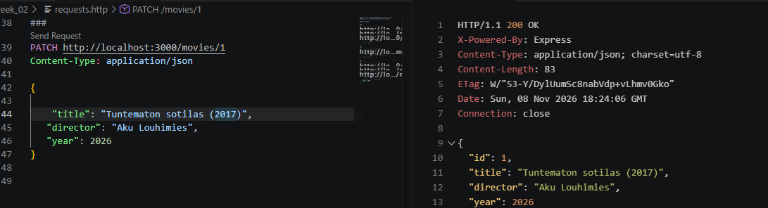
Figure 1.3.1
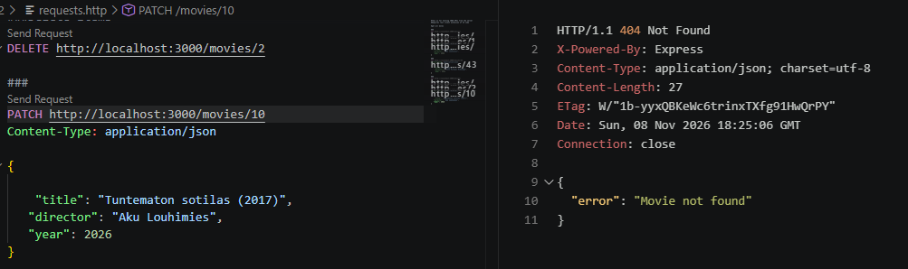
Figure 1.3.2
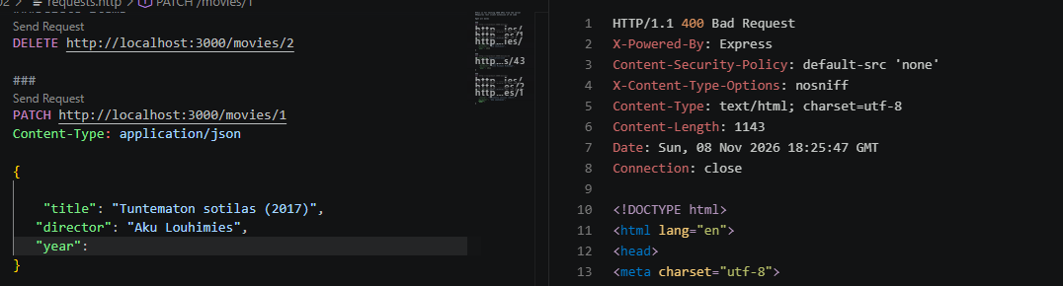
Figure 1.3.3
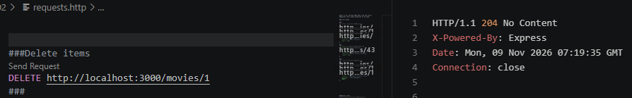
Figure 1.4.1
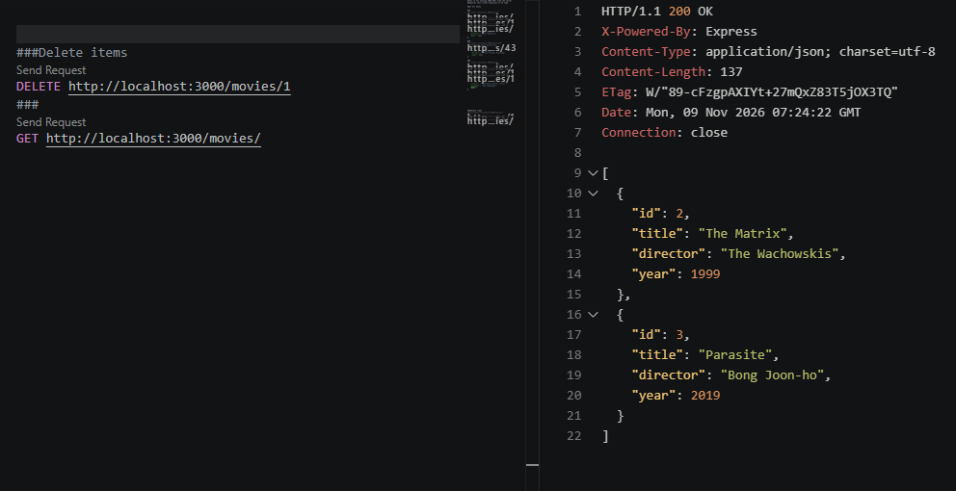
Figure 1.4.2
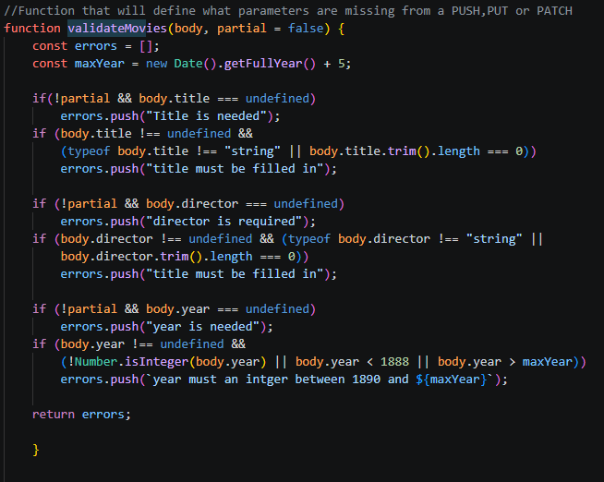
Figure 2.2.1
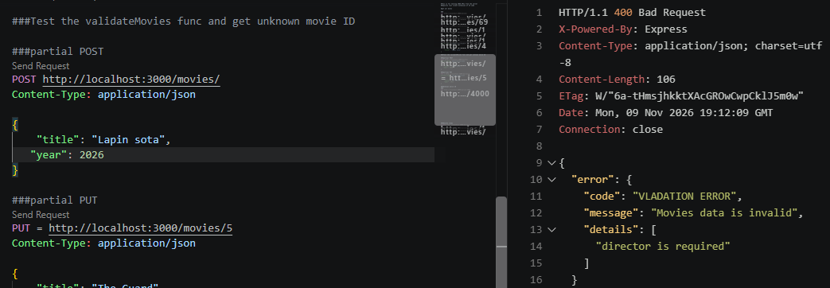
Figure 2.3.1
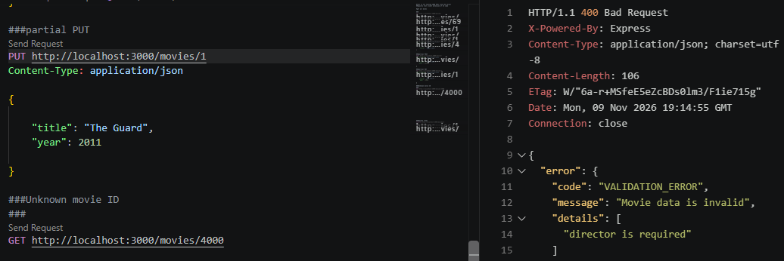
Figure 2.3.2
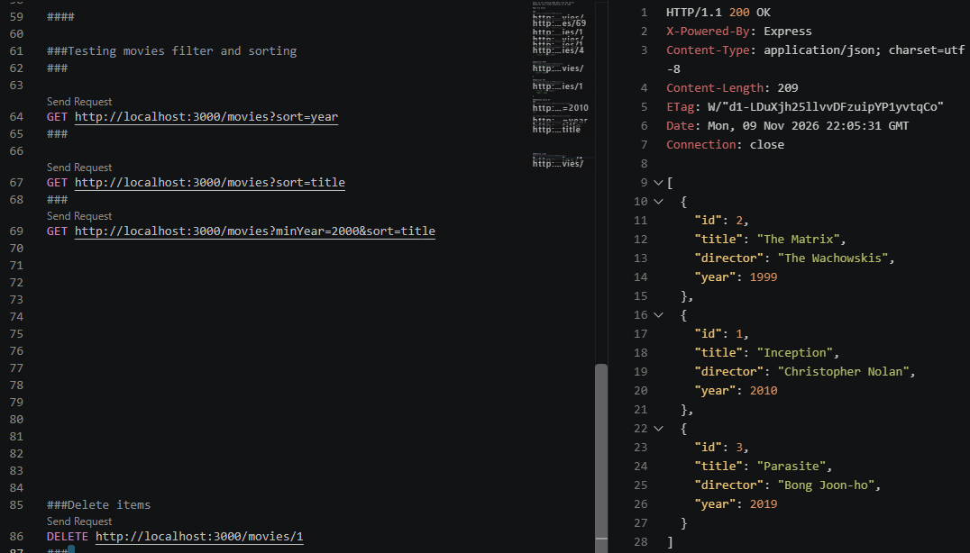
Figure 3.1.1
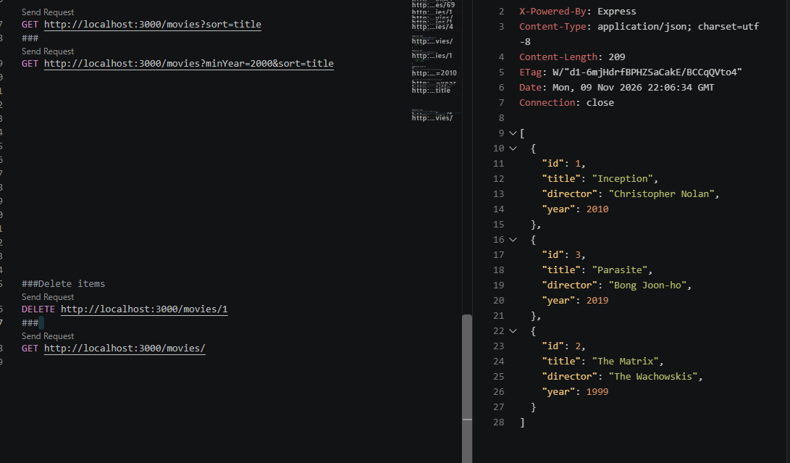
Figure 3.1.2
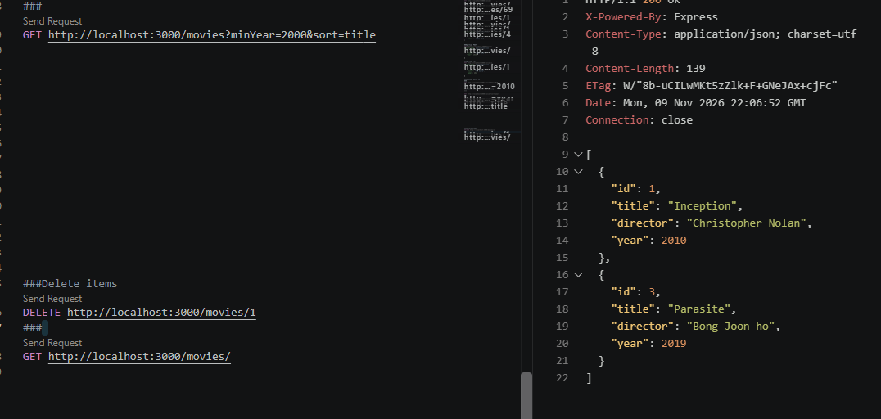
Figure 3.1.3
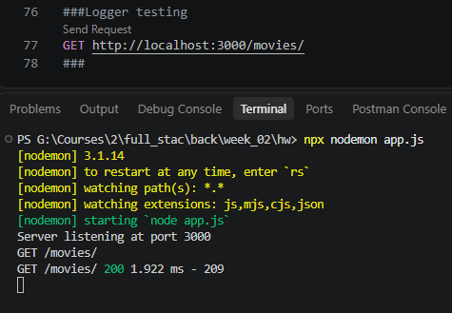
Figure 4.2.1
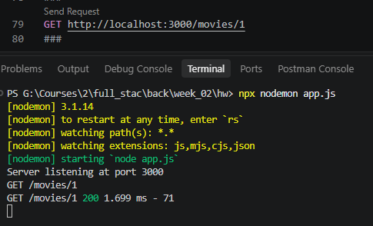
Figure 4.2.2
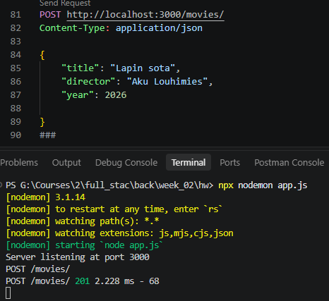
Figure 4.2.3
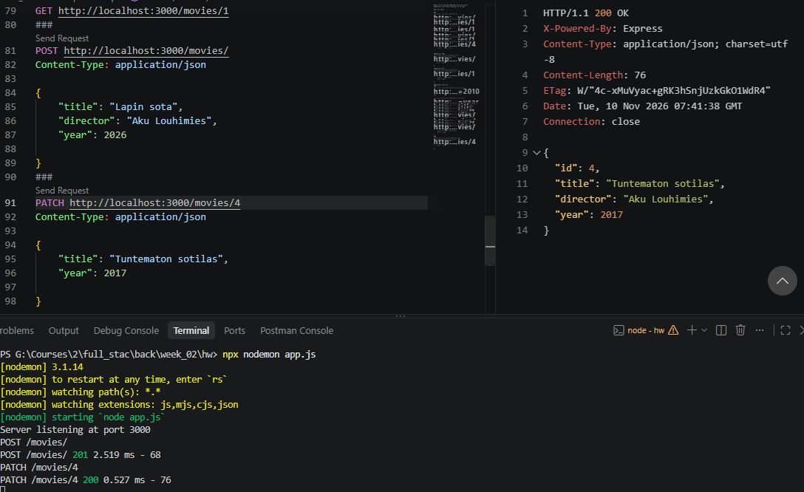
Figure 4.2.4
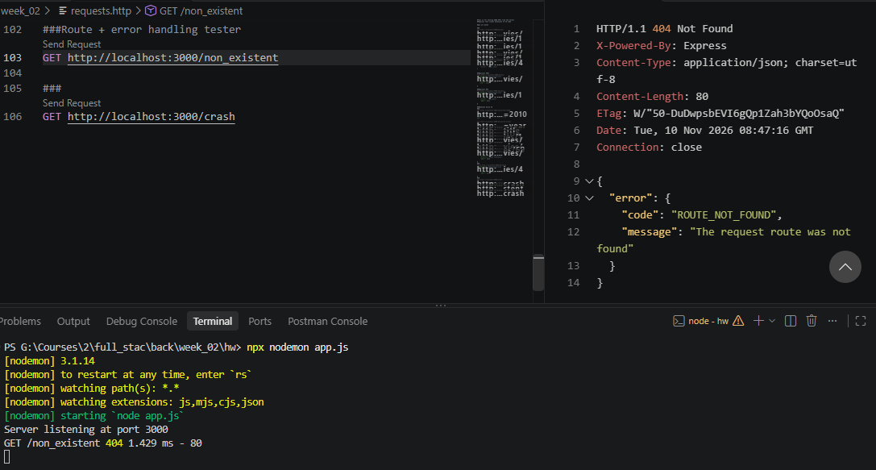
Figure 4.4.1
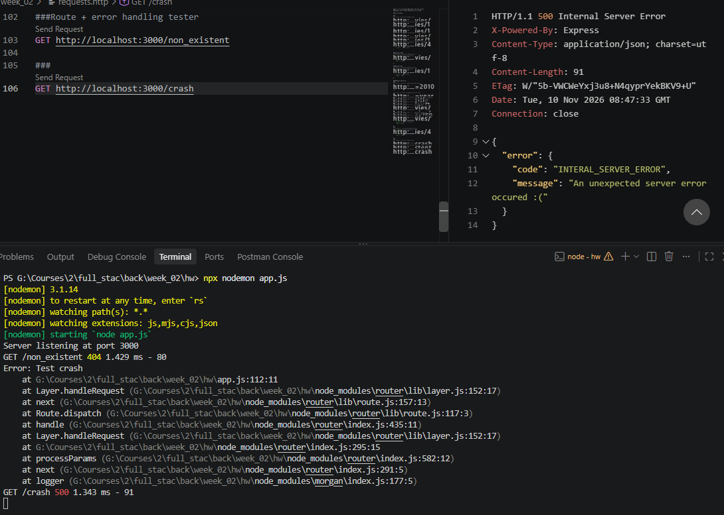
Figure 4.4.2
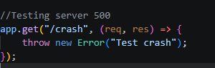
Figure 4.4.3
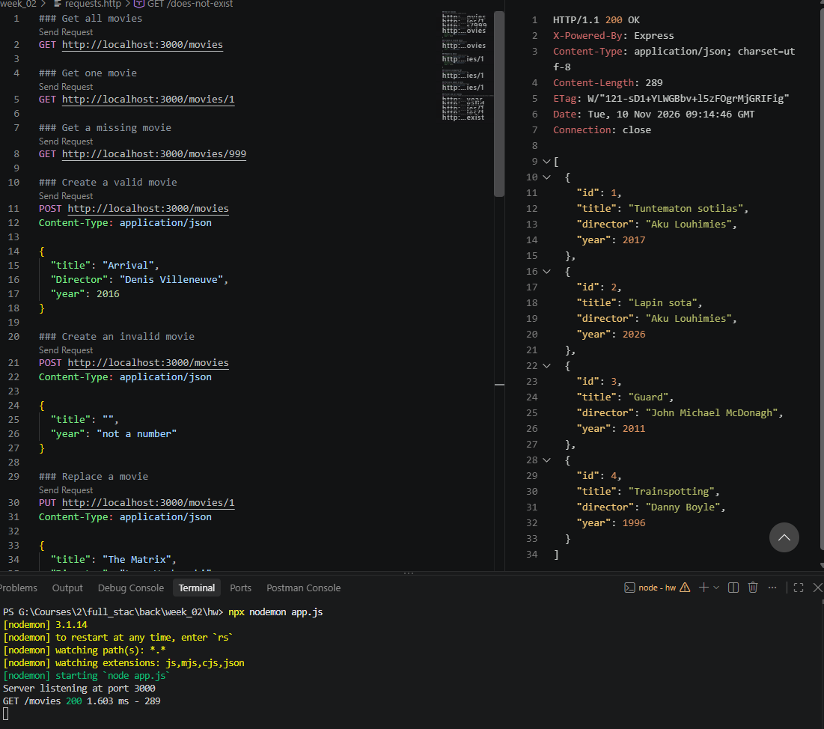
Figure 5.1
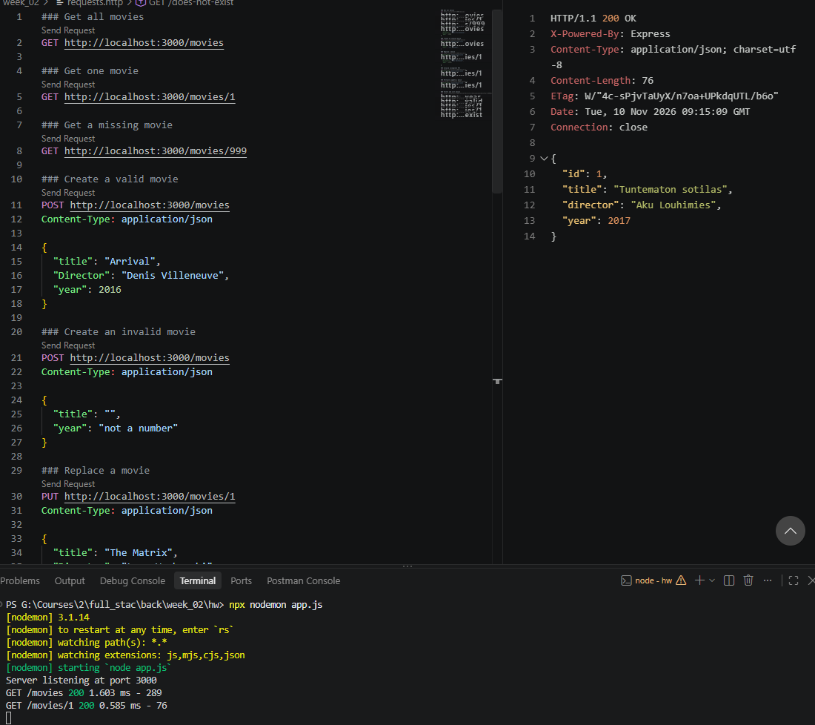
Figure 5.2

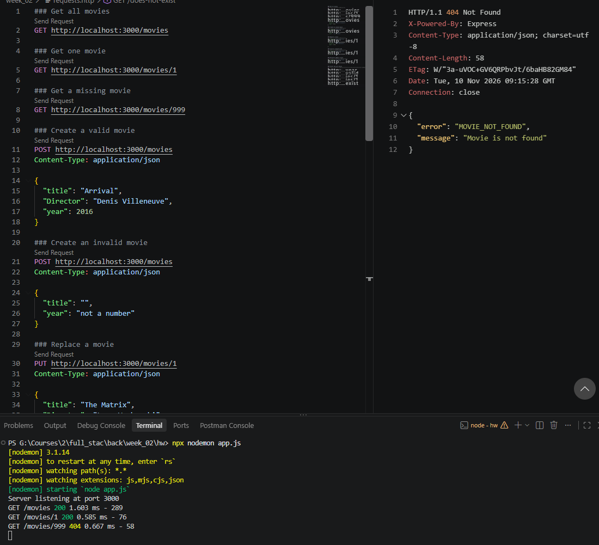
Figure 5.3
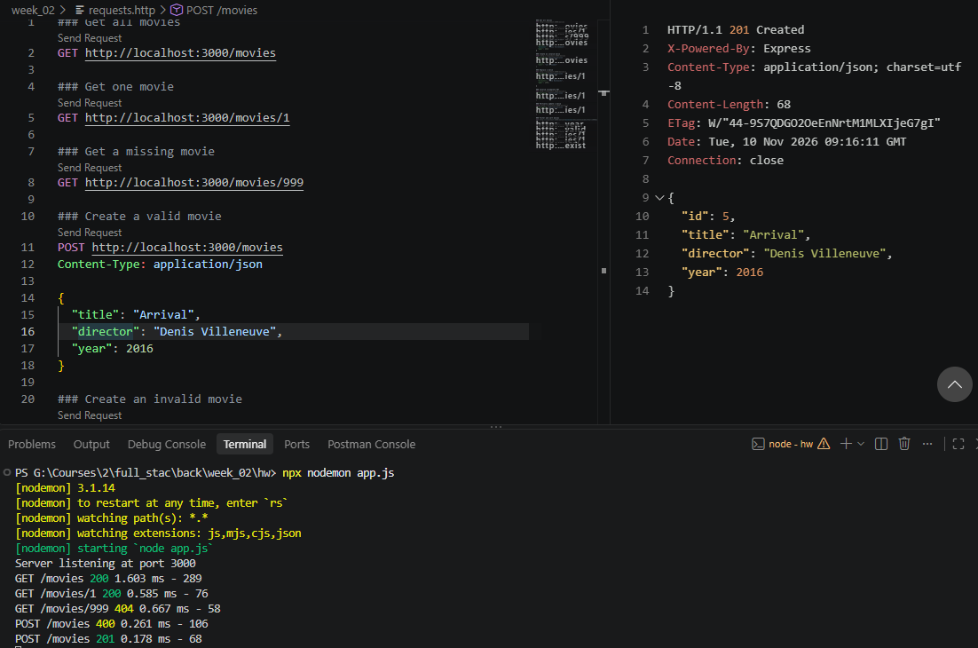
Figure 5.4
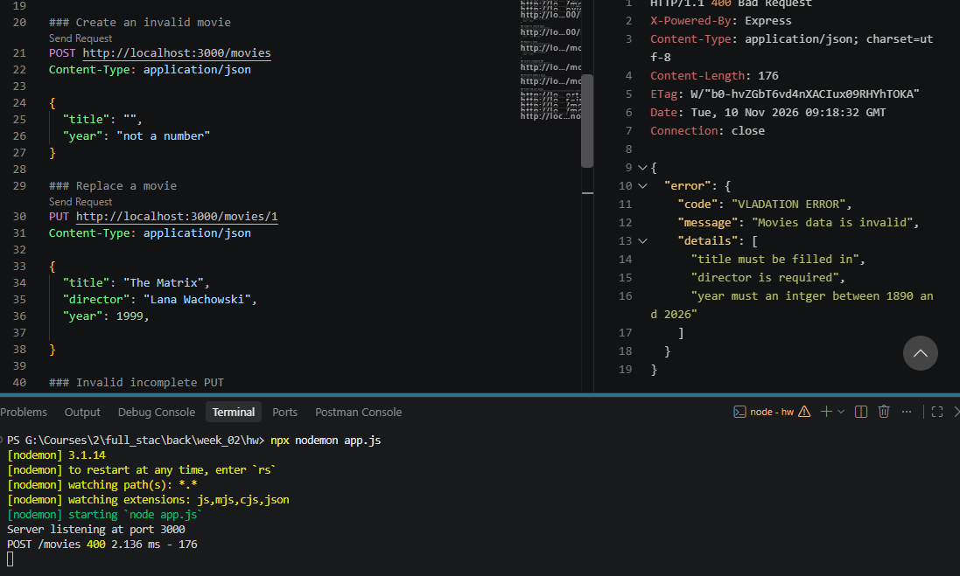
Figure 5.5
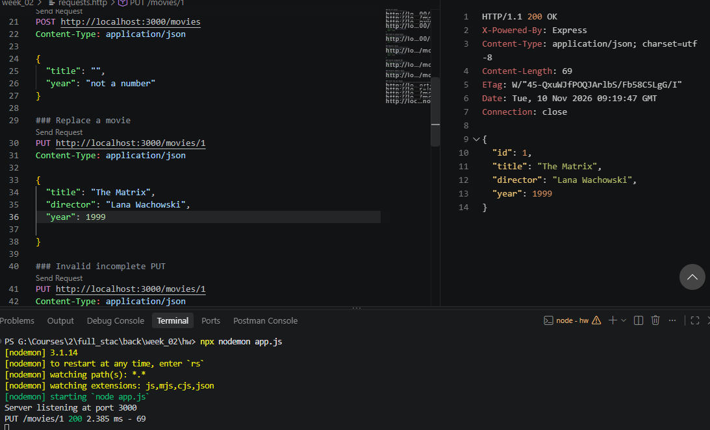
Figure 5.6
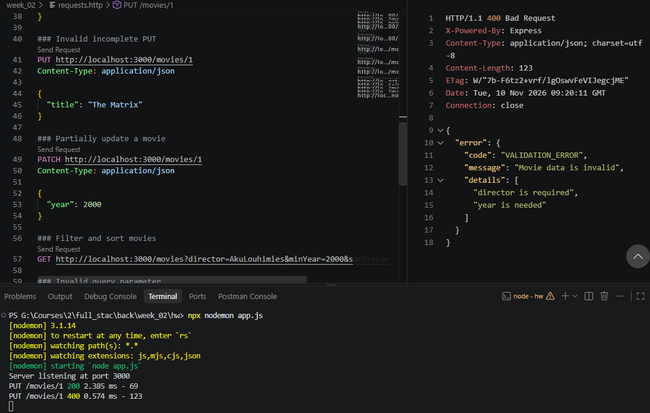
Figure 5.7
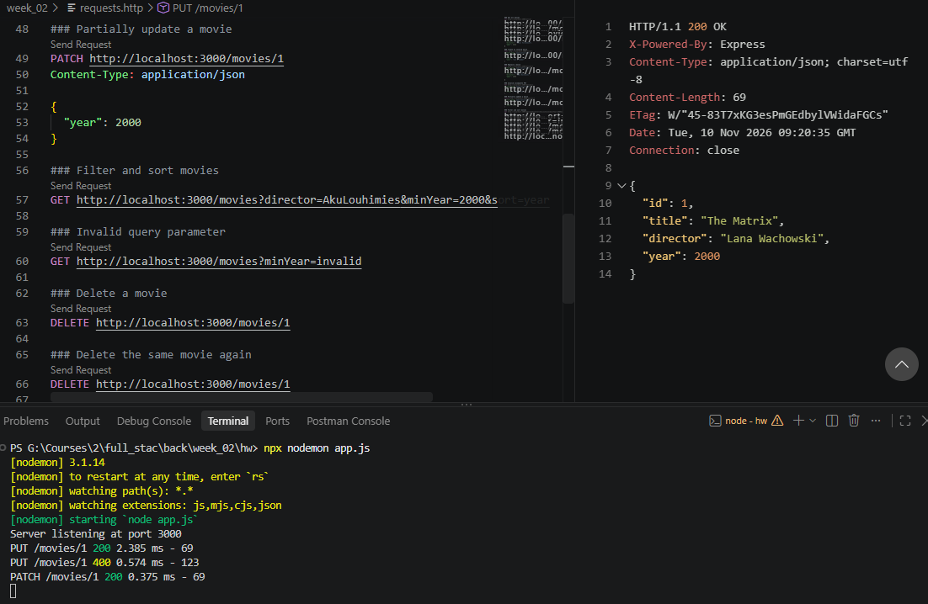
Figure 5.8
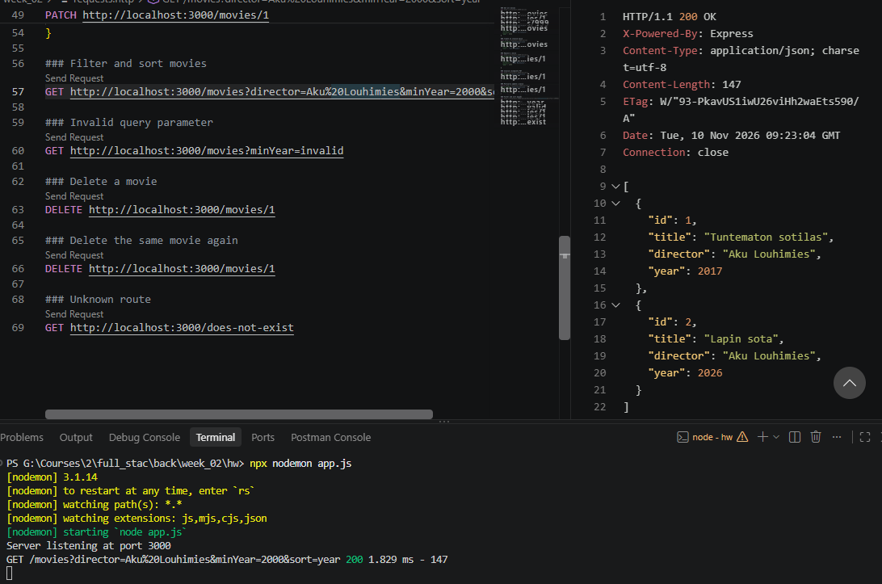
Figure 5.9
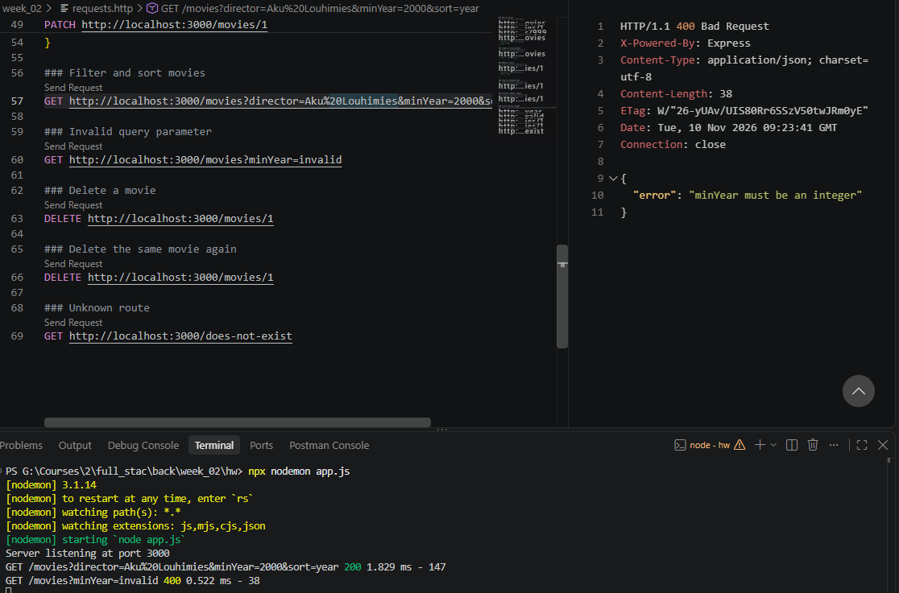
Figure 5.10
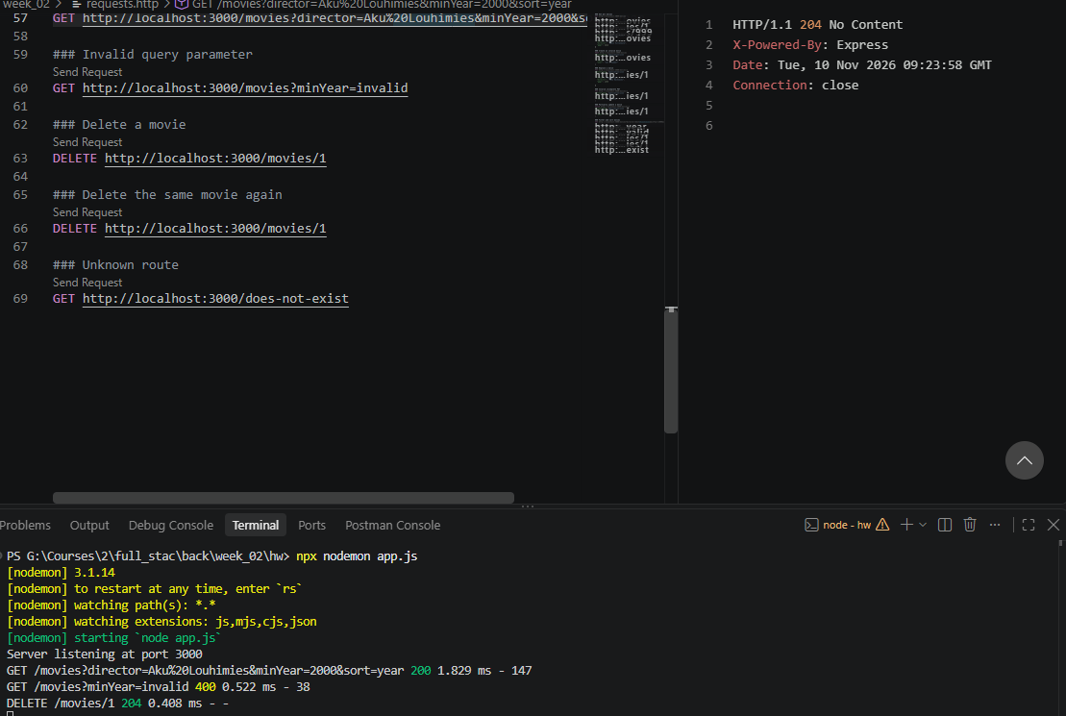
Figure 5.11
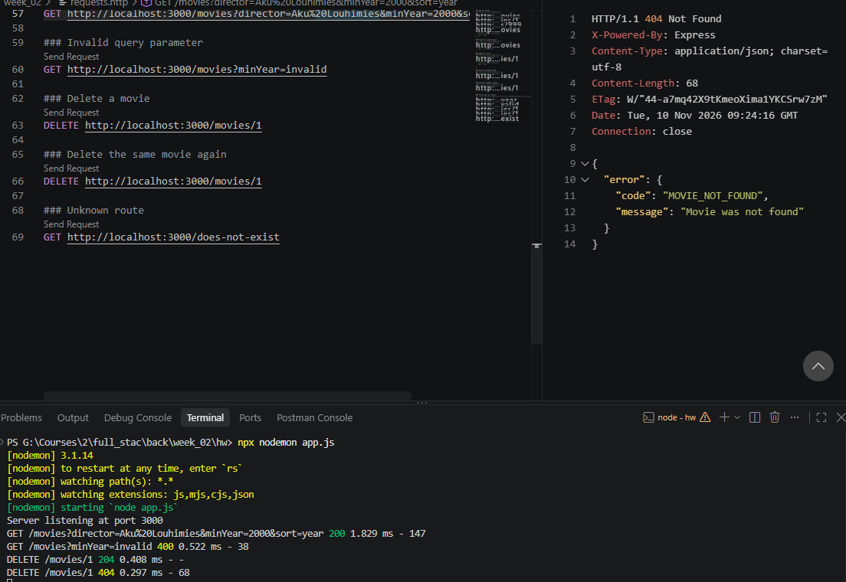
Figure 5.12
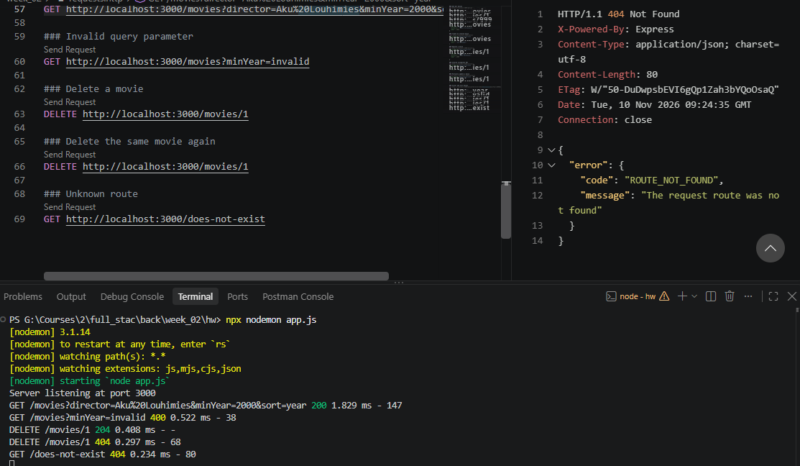
Figure 5.13

Week exercises

Week exercises

Week exercises

Sources used with exercises
List here all sources you’ve used with exercises (e.g. stackoverflow, tutorialspoint, github etc.)
Week 1 Exercises:
Course Moodle page
Lecturer’s slides
Youtube video for prettier : https://youtu.be/drtxWx1XojI
Stack overflow explaining node server saiving data:
https://stackoverflow.com/questions/57509086/is-storing-data-on-the-nodejs-server-reliable
Stack overflow REST client problem :
https://stackoverflow.com/questions/75051764/send-request-not-showing-in-rest-client
Week 3 Exercises:
Courses moodle page
Lecturers slides
Github : https://github.com/JebMN/backend

